**Course: Advance Bio Informatics**

**Module Title: Adoption Studies**

**Module No: 149**

**Why Twin Studies?**

Monozygotic (MZ) pairs (share same genotype). Dizygotic (DZ) pairs, like siblings, share on average half of their genes. Twin study is a Degree to which genetic factors contribute to etiology of a disease phenotype.

Genes & familiarity of complex traits or disease Effects of family studies. It has Twin and twin-family. Specific genes and specific environments.

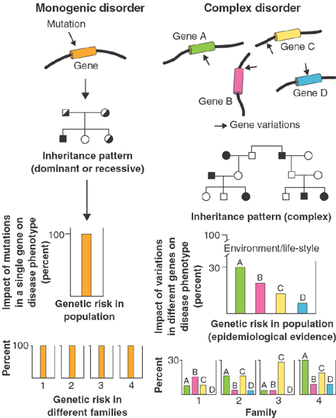

**Family Study**

Degree of Family aggregations risks to siblings, parents, and offspring as well as to other relatives. Similarity of different types of relatives can permit modeling of genetic versus non-genetic familial influences.

**Genes or shared family experiences**

**Twin studies:** Either family members sharing experiences but differing in shared genes

**Adoption studies:** Family members sharing genes, but differing in their shared experience

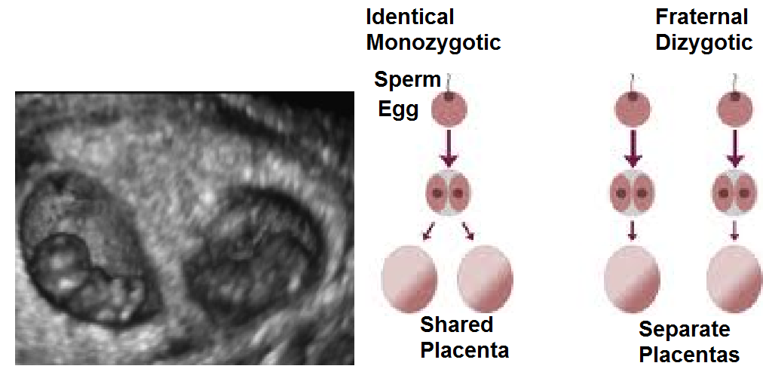

**Usage and Types**

* Twin studies are often used to assess genetic effects on variation in trait
* Comparing MZ/DZ twins can give evidence for genetic and/or environmental influences.

**Concordance Rate**

Do both twins show the same characteristic /trait?

Concordance rate

Trait MZ DZ

Height 95% 52%

IQ 90% 60%

* Proband- wise
* Pair-wise

Determining incidence of disease in twins helps delineate genetic & environmental components Genetic & environmental factors important.

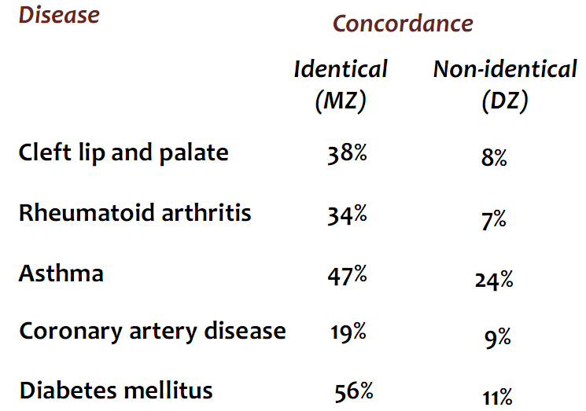

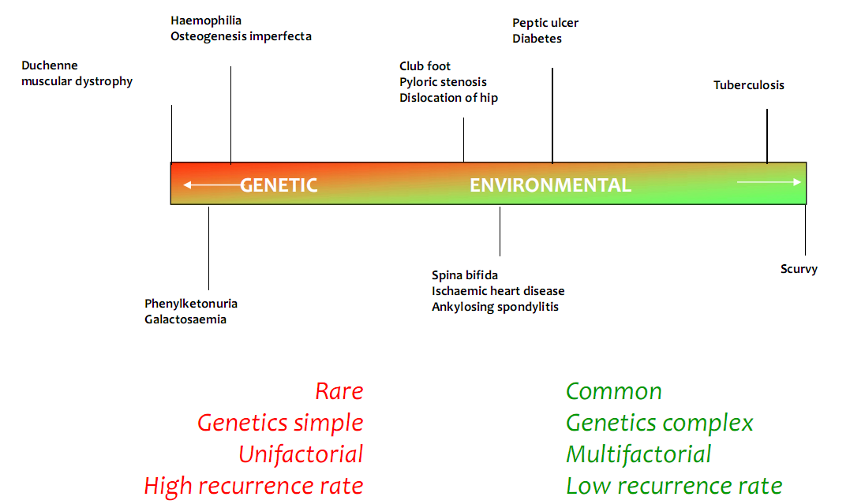

**Assumptions**

Equality of environmental variances in MZ & DZ Differences: placentation & *in utero* effects. Fetal programming hypothesis implications, differential parental treatment, zygosity determination errors and Random mating.